**ATTENDANCE SYSTEM USING FACE RECOGNITION**

*BY:SUVARNA LAKSHMI*

*20BDS0322*

**MY ROLE:**

I am doing this project alone. So most of the coding part is done by me .

**WHAT I LEARNED:**

While doing this project I learned how to install libraries which is required for face recognition. Although it is difficult to understand but it is interesting to learn more of the process involved to make this project. I also learned how to compare faces using numpy and dlib library. And also what was the algorithm behind this face recognition.

**COURSES TAKEN:**

I have not taken any courses for doing this project but referred some youtube videos to do this project.

**LIBRARIES INSTALLED**

* Pillow
* Click
* Cmake
* Dlib
* Face-recognition
* Face-recognition-models
* Numpy
* Opencv-python

**WORK FLOW**

1. First I have installed all the libraries listed above.
2. Then I imported them and stored all the images which are for sample for face-recognition are kept in same folder.
3. Using the library numpy and face-recognition I calculated the encodings in the face
4. After that I compared with the other set of images which are to be compared with the sample images by getting their encodings
5. The nearest value after comparing the face encodings is printed as true.

**SCREEN SHOTS**

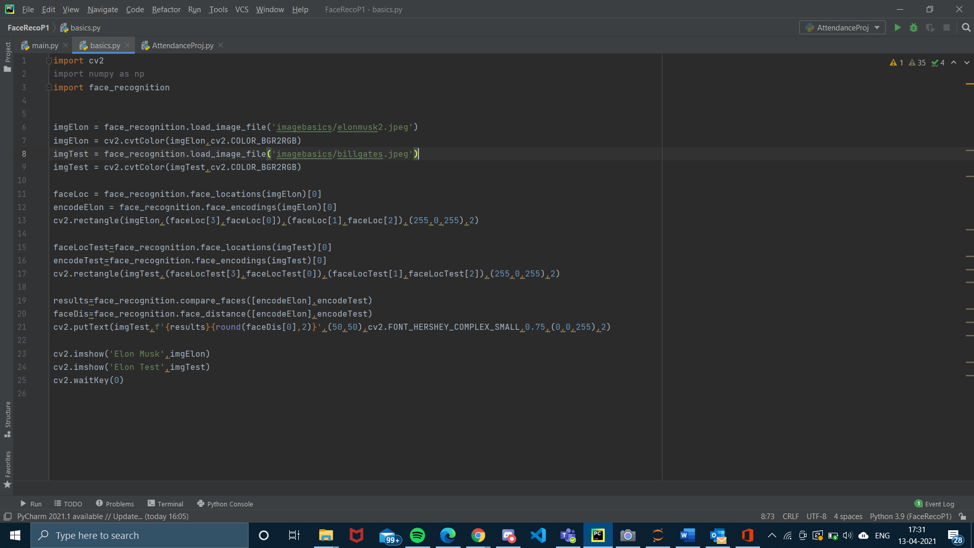

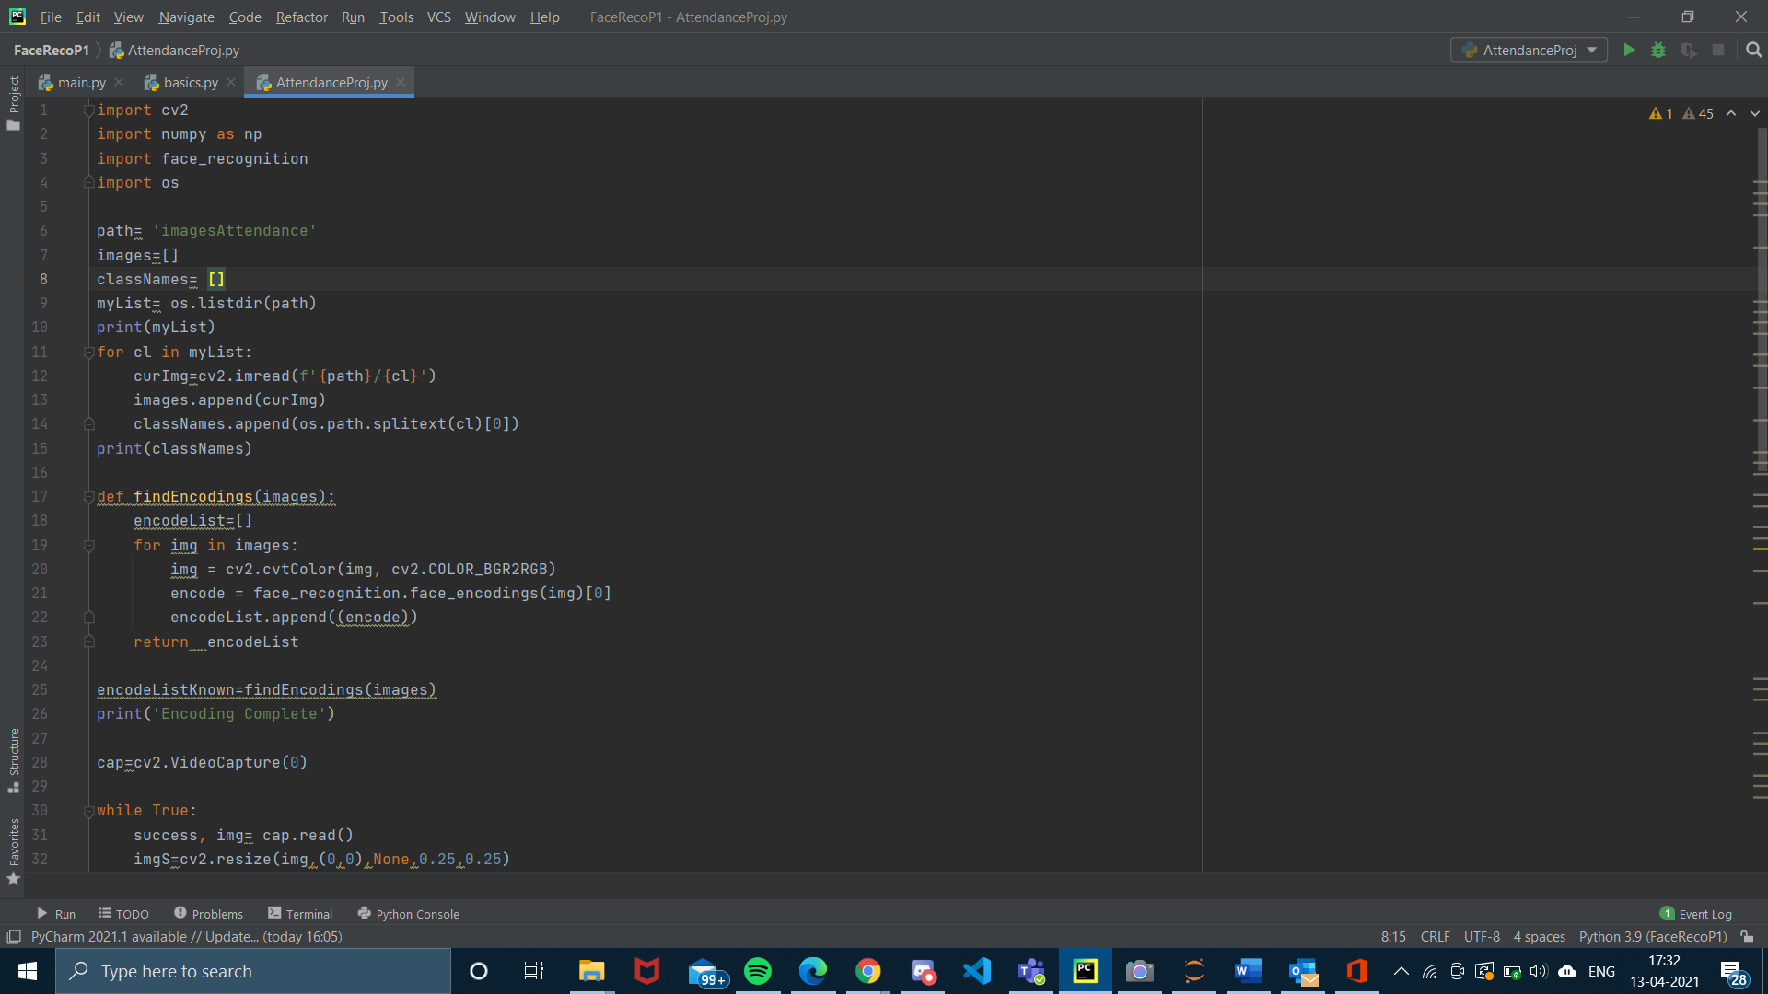

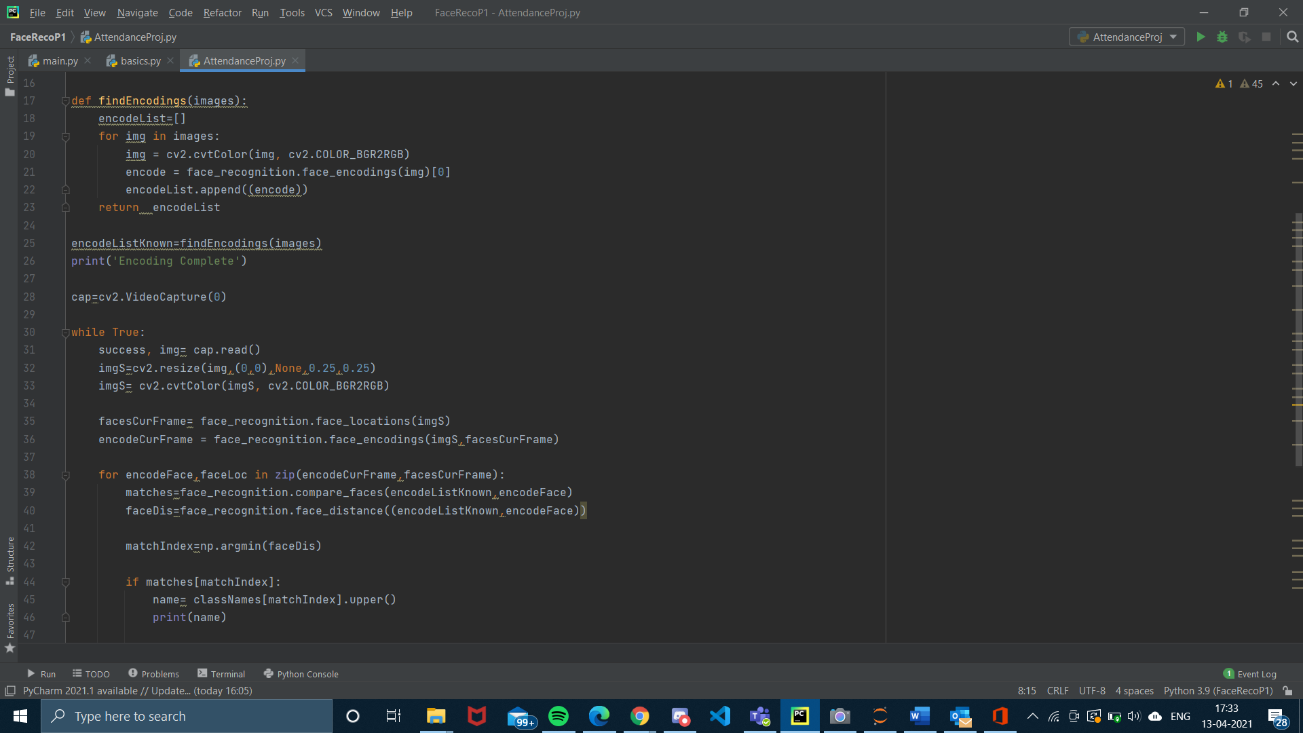

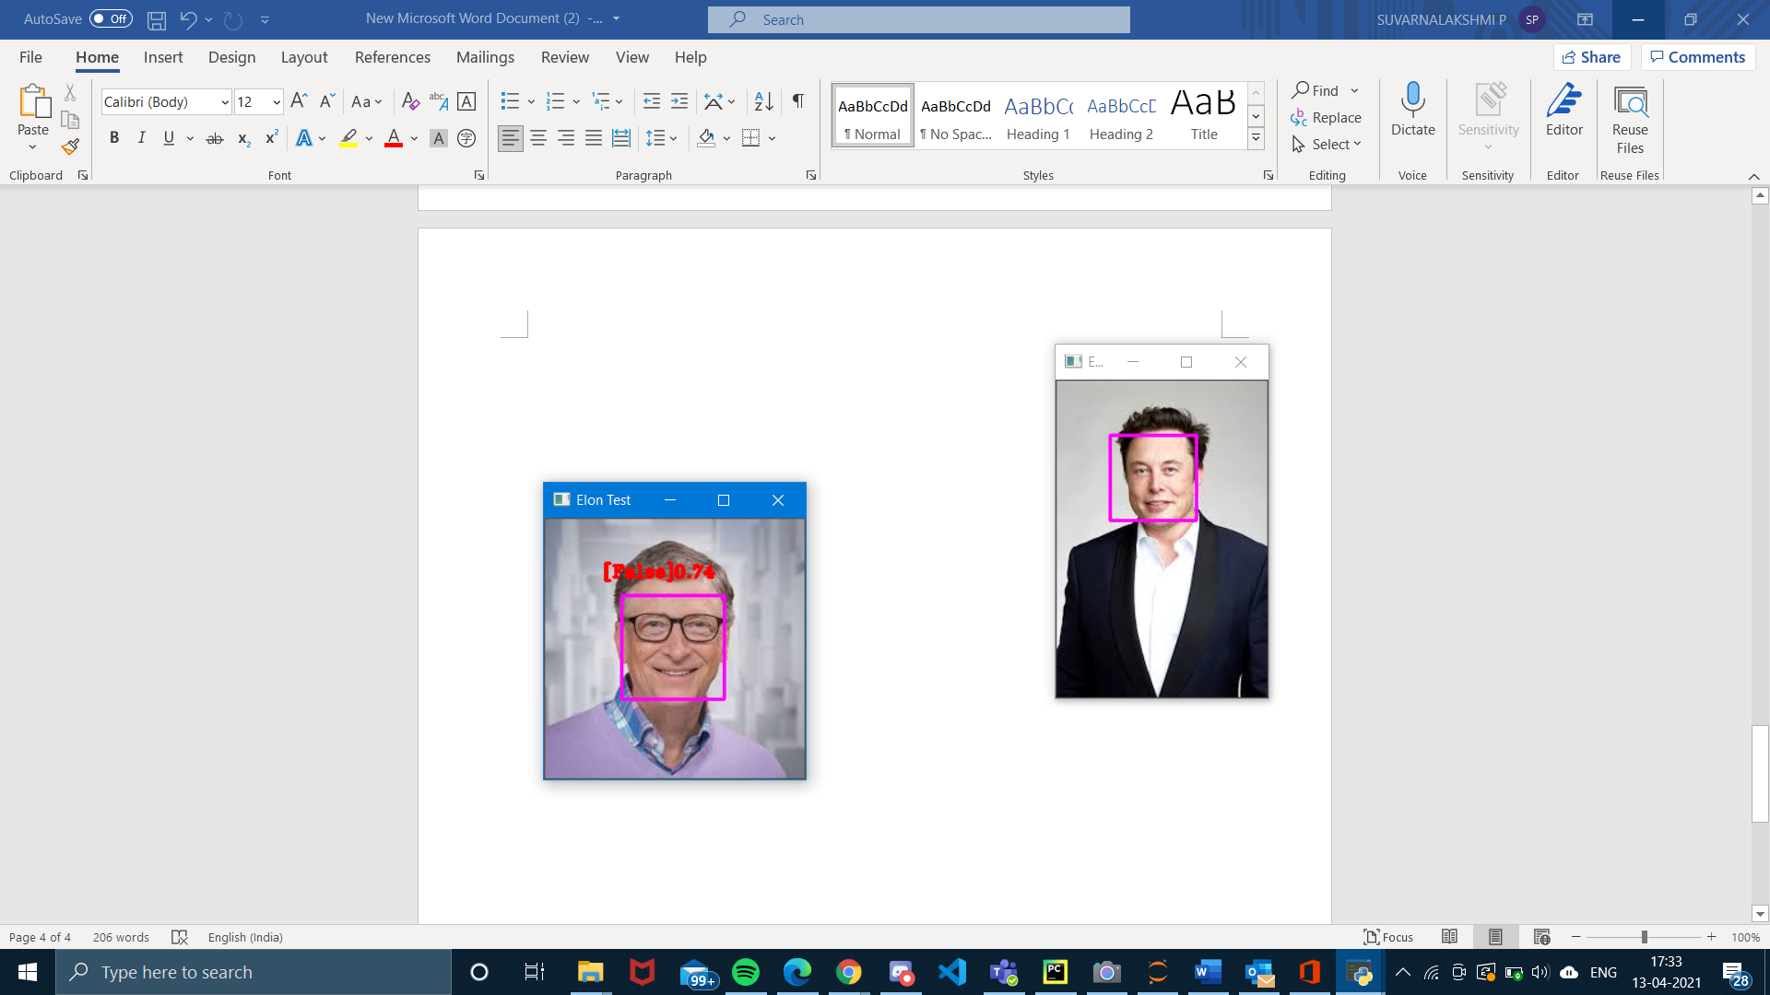

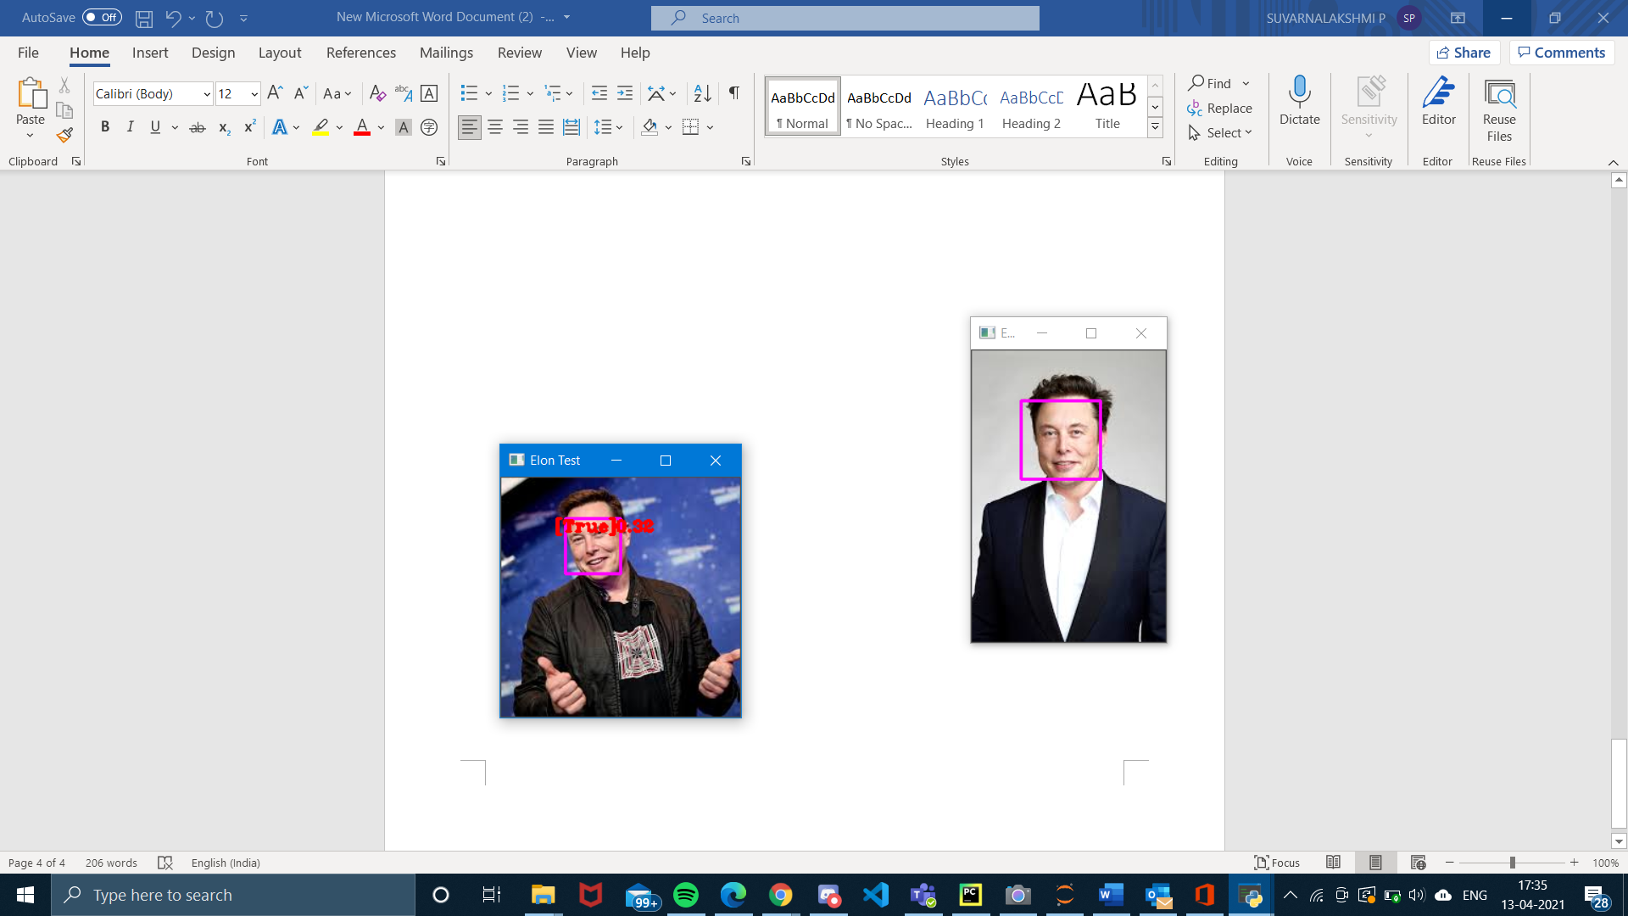

**GITHUB REPO LINK:**

https://github.com/suvarna-13/Attendance_FaceRecognition